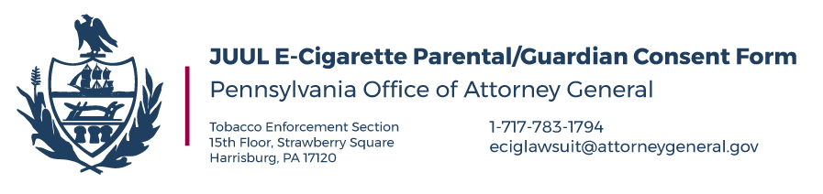

Dear parents and guardians,

As part of our effort to hold JUUL Labs, Inc. accountable for the harm its caused to Pennsylvanians, especially its young people, our Office is collecting stories from parents, teachers, and students to demonstrate to the Court the effects JUUL has had on the Commonwealth. However, before speaking to any students under the age of 18, we require their parent or guardian to sign this form to ensure that the student has permission to discuss this matter with our Office. By signing below, you hereby:

- Certify that (print name[s])___________________________________ is your child and they have your permission to correspond with our Office regarding the effects of e-cigarette use; that the Office of Attorney General has your permission to contact your child regarding the same; and that the information provided in your child’s complaint is true and correct to the best of your knowledge, information, and belief;

- Consent to the sharing of the information contained in your child’s complaint with other local, state, or federal law enforcement agencies as necessary for law enforcement purposes;

- Acknowledge that our Office is collecting such complaints to support our lawsuit against JUUL Labs, Inc., and your child may be asked to provide testimony as to how they have been affected by e-cigarettes in Court; and that the information contained within their complaint or subsequently provided to our Office may be subject to discovery, so such information may be disclosed to JUUL Labs, Inc., or other tobacco companies if additional actions are brought to which such information would be relevant;

- Acknowledge that submission of this complaint does NOT preserve any legal claim or right to sue any tobacco company, and that the Attorney General cannot act as your or your child’s private attorney;

__________________________________________________
PRINT YOUR NAME

__________________________________________________ __________________
YOUR SIGNATURE DATE

