**ATTACHMENT A**

**Item #1**

**24oz. Tritan Bottle With Stainless Steel Cap**

**THIS ITEM MUST BE A TRITAN BOTTLE (NO SUBSTITUTES)**

9.5" H x 2.75" Diameter

BPA free, meets FDA requirements

Grey/Black

Imprint area 5" h x 2" - one color (orange)

**Quantity – 1000**

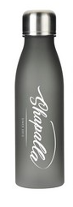

**Item #2**

**Lanyards**

Lanyard is made from a flexible polyester material.

Includes a detachable black clip with metal swivel hook for attachment purposes.

Complete with a breakaway safety snap for easy removal.

Size: 40" x 1" (20" for each side).

Navy with yellow imprint

**Quantity – 8000**

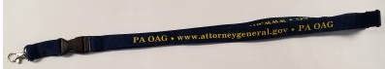

**Item #3**

**Drawstring Sportpack**

Minimum requirement – must be made from 80gsm non-woven polypropylene.

White bag

Includes a pair of shoulder straps that cinch the sportpack shut.

Size: 16-1/2" x 13".

One-color imprint on the front of the sportspack.

**Quantity – 10000**



**Item #4**

**Emery Boards**

Abrasive materials with a hardwood veneer core

Size: 1/2" x 4-5/8"

one-color imprint on the front

**Quantity – 10000  (would like bundled in 100)**



**Item #5**

**Microfiber Cleaning Cloth – Version 1**

Full color process imprint.

Dimensions:6" W x 6" H

Imprint Area:6" W x 6" H

**Quantity – 10000**

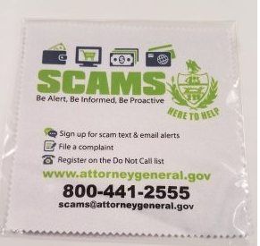

**Item #6**

**Microfiber Cleaning Cloth – Version 2**

Full color process imprint.

Dimensions:6" W x 6" H

Imprint Area:6" W x 6" H

**Quantity – 10000**

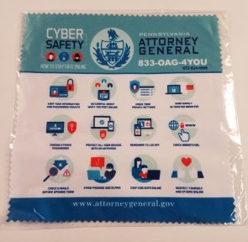

**Item #7**

**Microfiber Cleaning Cloth – Version 3**

Full color process imprint.

Dimensions:6" W x 6" H

Imprint Area:6" W x 6" H

**Quantity – 10000**

**DESIGN BEING DEVELOPED**

**Item #8**

**Large Grocery Tote**

Minimum requirement – must be made from 80 gram non-woven polypropylene bag features a durable bottom board, double 20 inch reinforced handles and is reusable and recyclable

Navy Tote

Size: 13" W x 14 1/2" H x 10" D

Imprint Area: 5" W x 10" H

Two color imprint preferred

**Quantity – 4000**

**DESIGN BEING DEVELOPED**

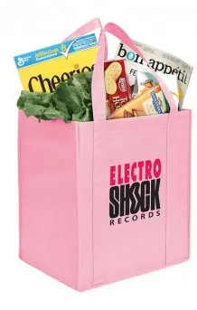

**Item #9**

**Clear Translucent School Kit**

Clear Translucent Packet with colored trim,  1 Round Pencil - 1 Natural Finish 6" Wood Ruler - 1 Eraser - 1 Pencil Sharpener

Dark Blue/Navy trim

Dimensions: 9-1/4"W x 6"H

Imprint Area: 2"H x 4"W

**Quantity - 2500**

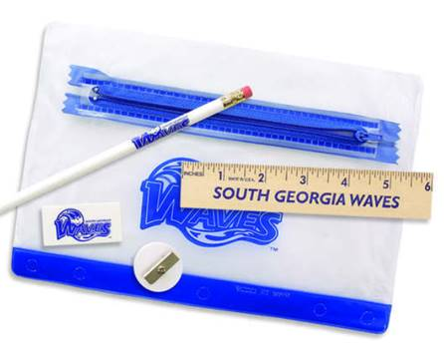

**Item #10**

**Storm Grip Pen – Version 1**

Blue

Dimensions: 5-3/8"L x 15/32" Dia.

Imprint Area: 1-1/4"W x 5/8"H

**Quantity – 5000**

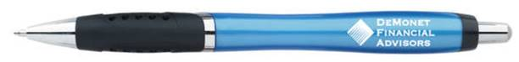

**Item #11**

**Storm Grip Pen – Version 2**

Red

Dimensions: 5-3/8"L x 15/32" Dia.

Imprint Area: 1-1/4"W x 5/8"H

**Quantity – 5000**

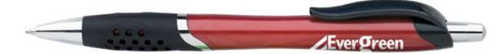

**Item #12**

**Adhesive 3" x 3" x 1 1/2" Cube**

4-color process imprint on 4 sides - Imprint may be different on each side.

Imprint on individual sheets.

Imprint Area:  2.625" H x 2.625" W

Imprint Area:  1.103" H x 2.625" W

Imprint Method: Four Color Process

**Quantity – 2160**

**DESIGN BEING DEVELOPED**

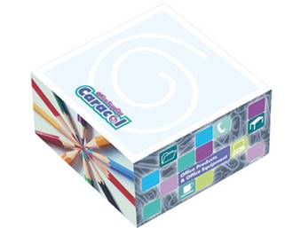

**Item #13**

**Promotional Clip-On Flashing Reflector Light**

Plastic hook with round light, three LED light settings (solid, blinking, flashing left to right).

Press on/off button power and function switch on back.

Hanging clip.

Button cell batteries included and inserted.

Approximate Size: 3.312" H X 2.562" W

Red and blue mix

Imprint Area:  2" x 2" (One Color Imprint Only)

**Quantity – 5000**

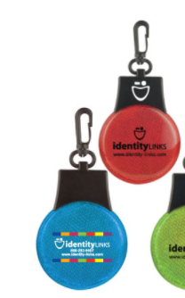

**Item #14**

**Imprinted 16 Words Picture Frame Magnet – Version 1**

Size: 5¼” W x 6¼” H

Imprint Area: 5¼” W x 6¼” H

Style: Personalized Picture Frame Magnets with Logos

Magnet Thickness: .020

**Quantity - 5000**

**DESIGN BEING DEVELOPED**

**Item #15**

**Imprinted 16 Words Picture Frame Magnet – Version 2**

Size: 5¼” W x 6¼” H

Imprint Area: 5¼” W x 6¼” H

Style: Personalized Picture Frame Magnets with Logos

Magnet Thickness: .020

**Quantity - 5000**

**DESIGN BEING DEVELOPED**

**Item #16**

**Imprinted 16 Words Picture Frame Magnet – Version 3**

Size: 5¼” W x 6¼” H

Imprint Area: 5¼” W x 6¼” H

Style: Personalized Picture Frame Magnets with Logos

Magnet Thickness: .020

**Quantity - 5000**

**DESIGN BEING DEVELOPED**

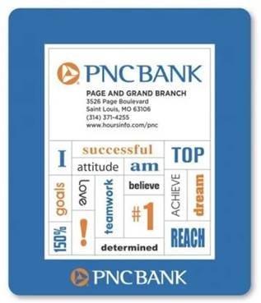

**Item #17**

**Silicone Ink Injected Wristbands**

3 different wristbands, each with a separate message and color – will inform

½ inch width size

**Quantity – 50,000**

